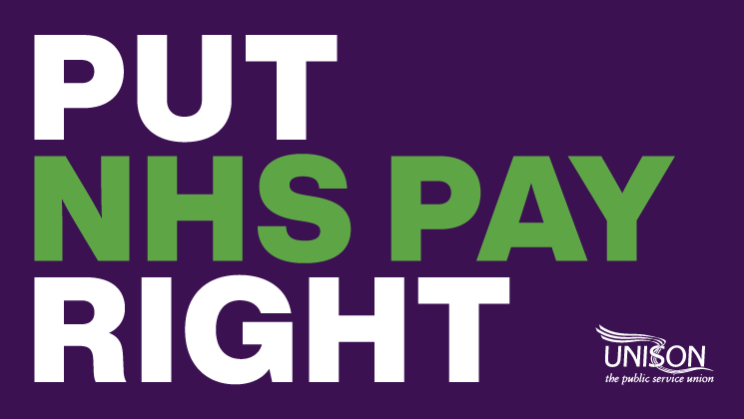
PUT NHS PAY RIGHT – UPDATE MAY 2022 – FOR AMENDMENT AND SHARING ON BRANCH NETWORKS

Staff unions submitted a pay claim for all NHS staff covered by Agenda for Change pay rates on 10 March 2022. The claim calls for an above inflation pay rise amongst other things.

Having received no response a letter was sent direct to Humza Yousaf the Cabinet Secretary for Health and Social Care – as at, 12 May that letter has not been responded to.

Employers and civil servants from Scottish Government have held an informal meeting with representatives of the staff side unions.

The outcome of that meeting was a commitment by them to start negotiations and dates are being canvassed for a pay negotiation meeting towards the end of May.

Head of Health for UNISON Scotland Matt McLaughlin said,

“UNISON is ready, as are our other trade union colleagues and we absolutely recognise the frustration that UNISON members are facing as process go up, workload demands increase and short staffing issues bite even deeper than before.

It is unacceptable that it has taken more than two months to get a date in the diary to discuss NHS workers pay.

With the Scottish Government now looking for dates to meet, all eyes are on them to see just how much they value our NHS workforce.”

Dawn MacDonald, Branch Secretary, UNISON Highland Healthcare, said,

“I was there when Humza Yousaf attended the UNISON Scotland Health Conference on 1 April, and he told that meeting that NHS pay was a priority. More than two months and we don’t even have an offer to consider, whilst members bills go up and up, and work pressures are ongoing and relentless. UNISON members across NHS Highland and Argyll and Bute are rightly angry that despite assurance the Cabinet Secretary seems to have forgotten his commitment. We however will not let him forget.

It’s time for him and his officials to step up ‘Put NHS Pay Right’.”

Do you want the Scottish Government to put NHS pay right?

You can help us by:
- writing to Humza Yousaf MSP and your local MSP https://action.unison.org.uk/page/102826/action/1
- Make sure your details are up to date
https://www.unison.org.uk/my-unison/
- And keep in touch with the UNISON campaign by checking our website https://unison-scotland.org/its-time-for-the-scottish-government-to-put-nhs-pay-right-in-2022/
- Talk to your colleagues in the workplace and encourage to send a letter to Humza Yousaf MSP using the link above
- Encourage your colleagues to a part of UNISON
https://join.unison.org.uk/?gclid=Cj0KCQjw_4-SBhCgARIsAAlegrUAb9FhBRvw4WdGS-89KLIl20iDzRFTlyYg5mdUaAUow3IKQvxFs1kaAlElEALw_wcB&gclsrc=aw.ds

